3

This electric circuit is set up on the bench.

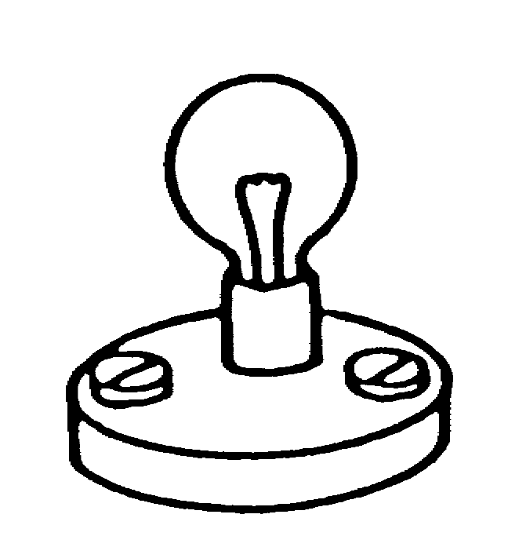
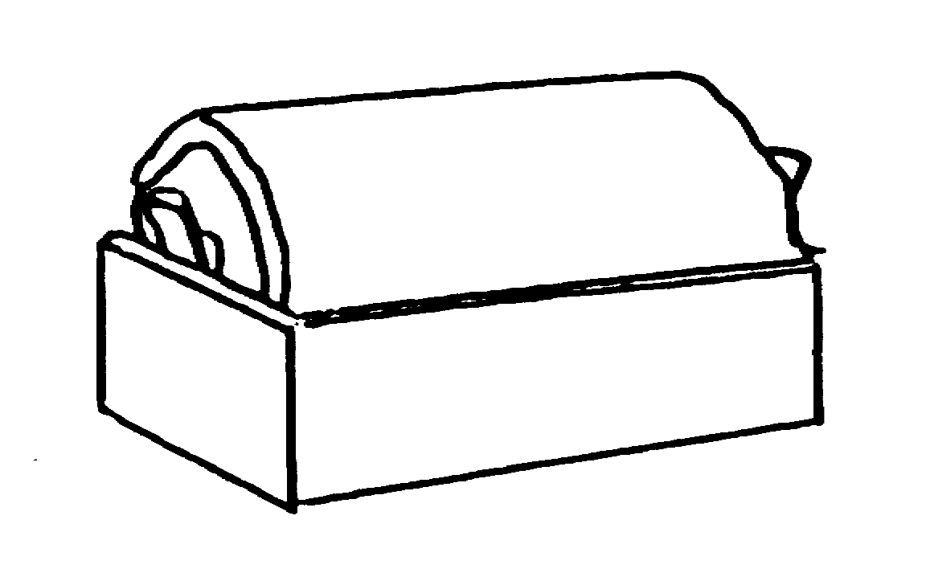
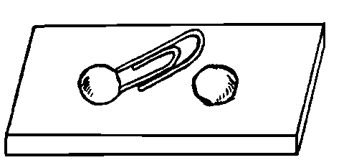

Five pupils are asked to draw its circuit diagram. Their drawings are shown below. For each, put a tick () in one box to show if you think it shows the connections in the circuit correctly or not.

a. b. c.
.

wrong
correct
.

wrong
correct
.

wrong
correct

d. e.
.

wrong
correct
.

wrong
correct

